QUICK EXAMPLE:
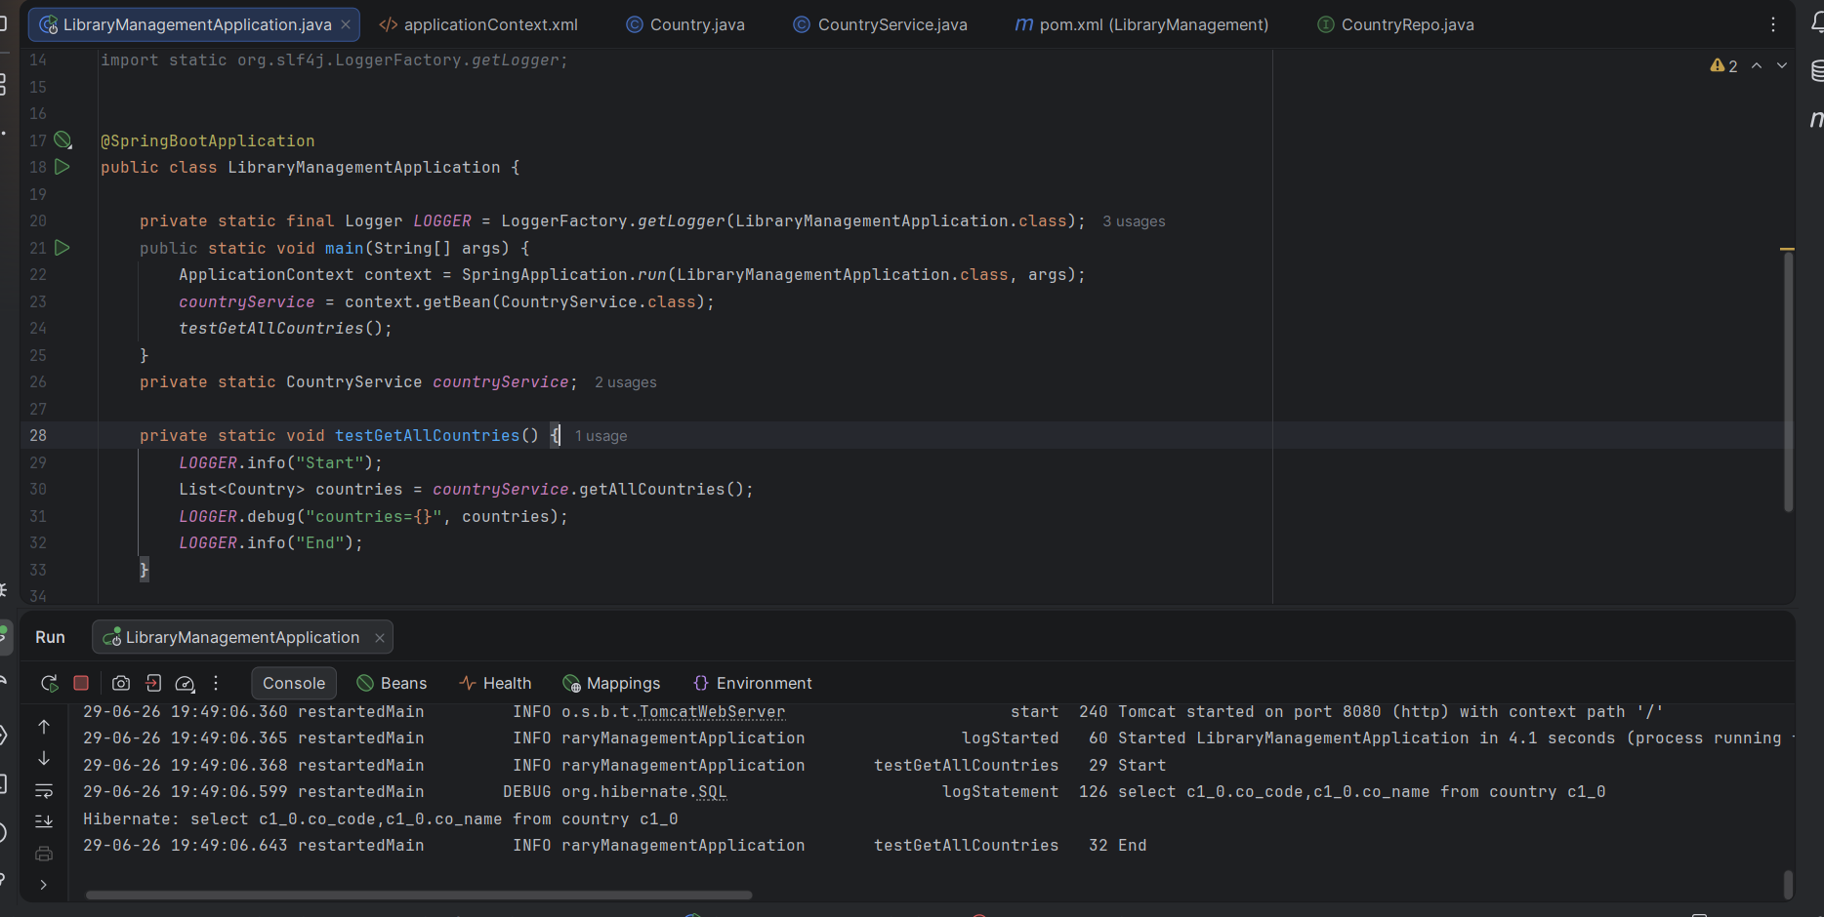

Difference between JPA, Hibernate and Spring Data JPA

